Contents

Pseudo Code 1

Test Data 9

User Guide 11

# Pseudo Code

**Level 1**

Run Program

Stop program when stats cause program to end.

**Level 2**

Run program

Set variables

Start timer

Decrease and increase stats accordingly.

When user clicks a button change stats as required.

Stop program when user presses quit or stat levels require the program to end.

**Level 3**

Set up Forms 1, 2 & 3 in design space. See screen shots.

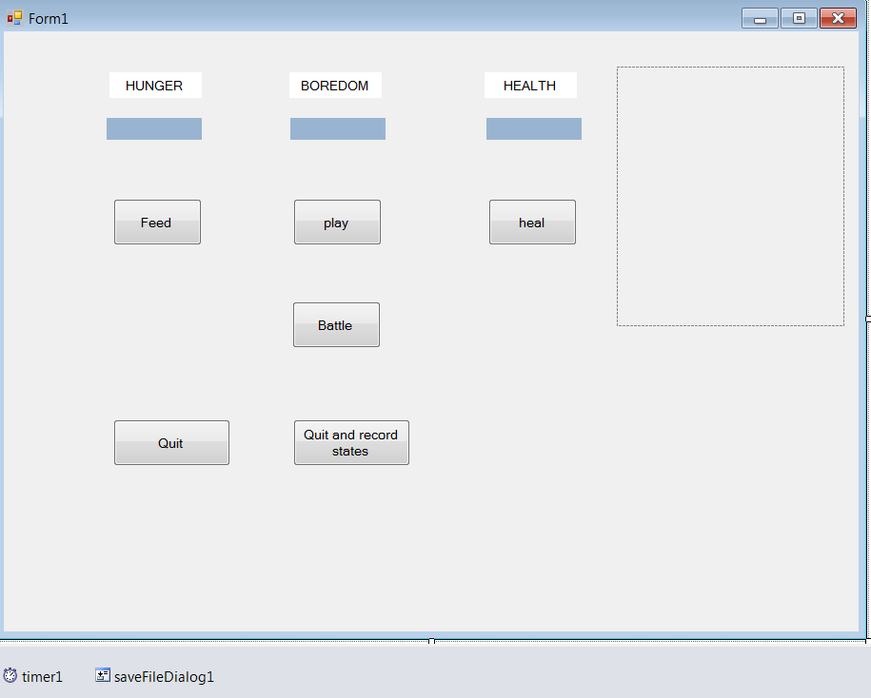

Form 1

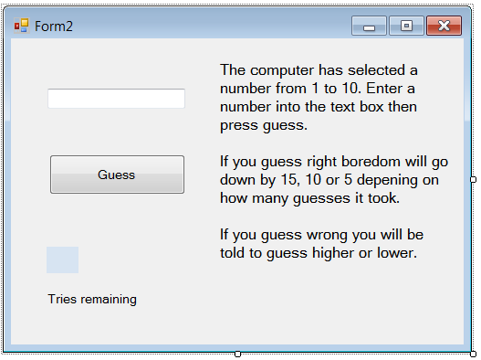

Form 2

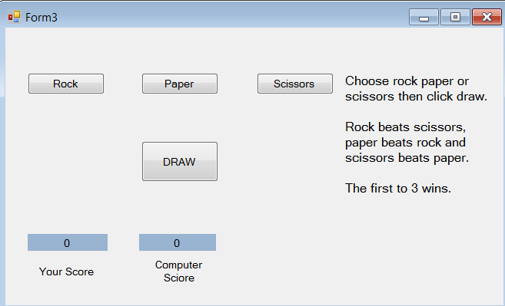

Form 3

Run program.

**Form 1**

Create Vpet class

Set health to 100

Set boredom to 0

Set hunger to 0

Method to alter hunger

If hunger – amount is less than 0

Set hunger to 0

If not

Perform the calculation

Store new value as hunger

Method to alter boredom

If boredom – amount is less than 0

Set hunger to 0

If not

Perform the calculation

Store new value as boredom

Method to alter hunger

If health – amount is greater than 100

Set hunger to 100

If not

Perform the calculation

Store new value as health

Get hunger value

Set hunger value

Get boredom value

Set boredom value

Get health value

Set health value

Set up user’s pet and computer controlled pet

Main part of form 1

Display NiceDog.jpg

Display starting stat values in corresponding labels.

Set timer interval to 2 seconds (2000 milliseconds).

Start the timer.

User presses Play button

Stop the timer

Switch to form 2

Set integer variable to take value from form 2

Change boredom stat by value taken from form 2.

Display new boredom value in label.

Restart timer.

User presses heal button

Health increased by 10 points

Display new health value in label.

User presses feed button

Hunger decreased by 10 points

Display new hunger value in label.

User presses battle button

Stop the timer.

If computer controlled pet has boredom value of 100 or more

Show message to say the pet has wandered off so can’t battle.

If computer pet has boredom of less than 100

Go to form 3

Set up integer to hold value taken once form 3 action is complete

Change all 3 stats by value from form 3.

Update all stats in relevant labels.

Restart timer.

User presses quit and save button

Stop the timer

Bring up the save file dialog box

User enters name of the file and location

File saved as .txt file

Hunger, boredom and health states written to the text file.

Program stops running.

User presses quit

Program stops running.

Each time the timer ticks

If health is less than 50 or boredom is over 50 or hunger is over 50

Display AngryDog.jpg

Else

Display NiceDog.jpg

Hunger and Boredom stats increased by 1.

Health stat decreased by 1.

Computer pet boredom increased by 2.

Update values in corresponding labels.

If health = 0 or hunger = 100 or boredom = 100

Display message stating pet has been recovered due to neglect

Display message showing ending values of each stat.

Program Stops Running.

**Form 2**

Set up public random number

Set up public integer to change pet boredom value

Set up public integers for repetition and user tries

Set up public integer for user guess

Public integer to choose random number from 1 to 10

Main part of form 2

Set guess text box to 0

Set tries label to 3

User presses guess button

Record text box entry as a string

Check this against numcheck method

If not a number

Display message stating not a number

Sets user choice to 0

Check if number is from 1 to 10

If not displays message stating number should be from 1 to 10

If is from 1 to 10

Checks if repetitions = 2 and the guess is incorrect

If this is true displays message stating the game is over

Boredom value is not changed

Form 2 closes and returns to form 1.

If the guess is correct

Switch statement based on repetitions

Repetitions = 0

Boredom decreased by 15

Repetitions = 1

Boredom decreased by 10

Repetitions = 2

Boredom decreased by 5

Form 2 closes and returns to form 1

If guess is too high

Display message suggesting a lower guess

1 added to repetition

If guess is too low

Display message suggesting a higher guess

1 added to repetition

Tries label is decreased by 1

**Form 3**

Set up public random number

Integer user choice defaulted to 0, computer choice, user score and computer score

User clicks rock button

User choice changed to 1

User clicks paper button

User choice changed to 2

User clicks scissors button

User choice changed to 3

User clicks draw button

If user choice = 0

Display message telling the user to click rock, paper or scissors first.

Computer chooses next random number from 1 to 3

If user choice and computer choice are the same

Display message stating it was a draw so no-one scores

If statements based on rock beats scissors, scissors beats paper and paper beats rock.

Add 1 to the winner of the round

When computer or user wins 3 rounds end the game

If user wins

20 added to health, 20 taken away from boredom and hunger

If computer wins

20 taken away from health, 20 added to boredom and hunger.

Close form 3 when winner declared and return to form 1.

# Test Data

# User Guide

Welcome to the vPet program. This is a simple program that sees you take control of a virtual pet; your pet will need to be fed when hungry, healed when sick and played with when bored. When starting the program you will come across this screen (see figure 1).

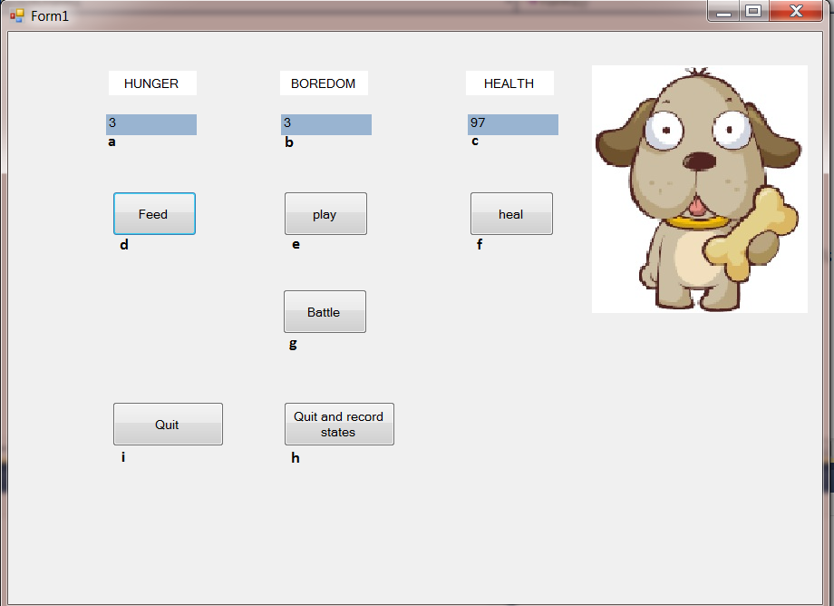

Figure 1

To help you understand what each of the lettered items does please read this guide.

1. This is how hungry your pet is, when it gets to 100 your pet will be rescued by animal shelter and the program will end.
2. This is how bored your pet is, when it gets to 100 your pet will be rescued by animal shelter and the program will end.
3. This is how healthy your pet is, when it gets to 0 your pet will be rescued by animal shelter and the program will end.
4. Click this button to feed your pet.
5. Click this button to play with your pet, this will bring up this new screen. (See figure 2).

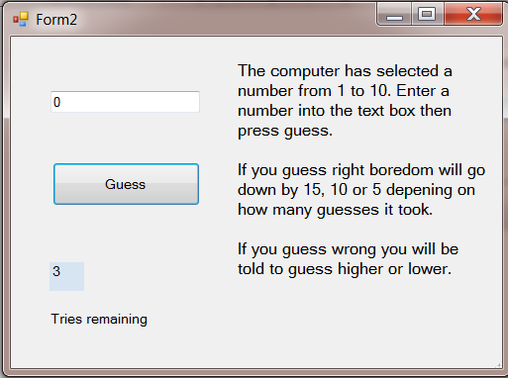

Figure 2

As you can see on the screen are the instructions for the game. Enter a number from 1 to 10 in the text box at the top then press guess. If you are correct you will be rewarded based on how many guess you took.

One guess decreases boredom by 15, two guesses by 10 and three by 5. After three guesses you will return to the main screen and the boredom value won’t have changed.

1. Click this button to heal your pet.
2. Click this button to battle against the computer controller pet, assuming the computer’s pet hasn’t got too bored and wandered off. This will bring up a new screen (see figure 3).



Figure 3

You battle the computer’s pet in the classic game of rock, paper, and scissors. Press one of the three buttons to choose then press draw. Should you and the computer pick the same no-one will score. If you win the round you will get one point, or one point will go to the computer if the computer wins. The first to 3 points will win the game. Should you win, 20 points will be added to health and 20 points will be taken from boredom and hunger. If you lose 20 points will be taken from health and 20 points will be added to boredom and hunger.

As always rock beats scissors, scissors beats paper and paper beats rock.

1. Press this button to bring up the save file dialog box (see figure 4).

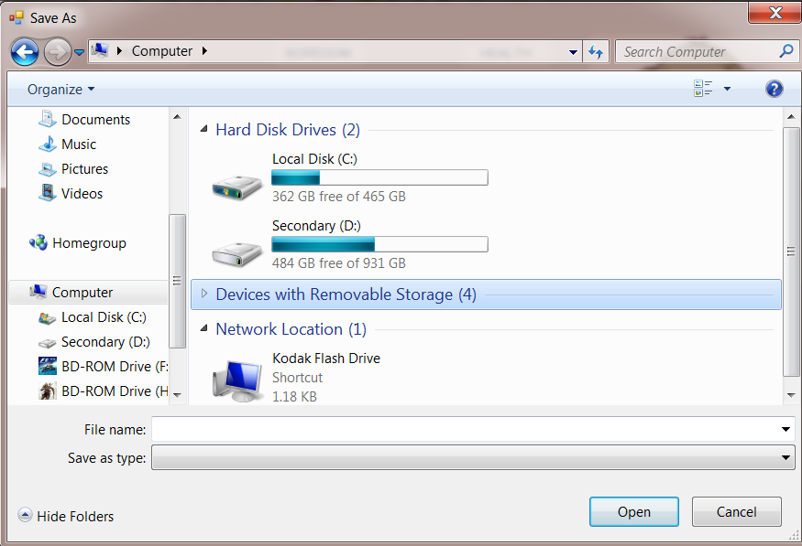

Figure 4

Here you can choose the location of where to save the file that shows all the states of your pet when you quit. This file will be saved as a .txt file. After the file has been saved the program will quit.

1. Press this button to quit without saving the states to a .txt file.

**The picture**

On the right hand side of the program there is a happy dog holding a bone (see figure 5).



Figure 5

If his health drops below 50 or his boredom or hunger get above 50 then he will get very upset and will show you (see figure 6).



Figure 6

This is your first clue that something is up so check his stats and try to make him happy again.